FEDERAL UNIVERSITY OF PETROLEUM RESOURCES, EFFURUN
SCHOOL OF POST GRADUATE STUDIES

SUBMISSION OF RESEARCH PROPOSAL

BY

OBIEBI - UYOYOU OGHENEMARO
ELECTRICAL /ELECTRONIC ENGINEERING

(INTRUMENTATION AND CONTROL OPTION)

TITLE OF PROPOSED TOPIC
PERSONAL COMPUTER MICROCONTROLLER - BASED PROCESS INSTRUMENT CONTROL SYSTEM FOR INDUSTRIAL OPERATIONS

SUPERVISED BY
Engr. Dr. Emmanuel Okhuelegbe

1.0 INTRODUCTION
In response to the issues and difficulties presented by his environment, man has been on a never- ending search to improve his well-being. The rapid automation of daily tasks brought on by technological development has raised the standard of living for people at home and in industries where the control of electrical devices and appliances is essential. The use of portable, reasonably priced computers has increased dramatically over the past few decades due to the attention and growth that computers and computer communication have received.
Automation, also known as automatic control, is the use of various control systems to control machinery, industrial processes, boilers, heat-treating ovens, telephone network switching, steering and stabilization of ships, aircraft, and other equipment with little to no human assistance. The main advantages of automation are labor, energy, and material savings, risk and accident reduction, and quality, accuracy, and precision improvement. In industrial automation, wireless communication technologies are frequently used.
The simplicity of computer-interfacing systems for managing and controlling devices is growing quickly. The computing and information technology that a user employs will respond to his or her demands, working to advance his or her comfort, convenience, security, and enjoyment; this kind of system is referred to as a "smart control system." Numerous control systems, from sophisticated to simple, have been created as technology has advanced. Today, one of the most common type of smart control system is the Smart Home, where all appliances in a home is remotely controlled with a mobile phone.
The proposed project (Personal Computer Microcontroller - Based Process Instrument Control System for Industrial Operations), is a smart control system where industrial devices can be controlled by using a personal computer (PC) as an interface which reduces risk and accident, increase productivity and reduces cost. System operators can be use to control instruments remotely and also get report data from them such as temperature reading , start and stop process pump, switch on and off process heater. The project is in trend with future technological advancement popularly known as industry 4.0.
Industry 4.0 was coined in 2011 by a German initiative of the federal government with universities and private companies. It was a strategic program to develop advanced production systems with the aim of increasing productivity and efficiency of the national industry
(Kagermann et al., 2013). This concept represents a new industrial stage of the manufacturing systems by integrating a set of emerging and convergent technologies that add value to the whole product lifecycle (Dalenogare et al.,...2018).
A key part of industry 4.0 is the ‘Front-end technologies’ which considers the transformation of the manufacturing activities based on emerging technologies (Smart Manufacturing) and the way product are offered (Smart Products) (Dalenogare et al., 2018) and smart control system have its role to play. In the Industry 4.0 environment, the interconnected computers, smart materials, and intelligent machines communicate with one another, interact with the environment, and eventually make decisions with minimal human involvement (Gilchrist, 2016).

1.1 PROBLEM STATEMENT
It has been observed that manual control for industrial equipment in the industrial sector have several challenges associated with it, which include:
- The switch operator's life could be put at risk.
- Damage of industrial equipment.
- Time wastage.
- Expensive
- Customer dissatisfaction.
As a result of the outlined issues with manual control system, the development of a system capable of controlling Process instrument via a computer system is intended. The system's goal is to solve the associated problems.

1.2 AIM AND OBJECTIVE
The goal of this project, "Personal Computer Microcontroller - Based Process Instrument Control System for Industrial Operations," is to create software and hardware for a microcontroller-based process instrument control system. As a result, the completed work can be viewed as a system with three main features that serve as the work's objective.

- Reduces the time spent moving between instruments to turn on or off industrial equipment by allowing instruments to be controlled remotely (computer system).
- Has a program control switch that will help to minimize, if not totally eliminate, the usage of manual switches.
- Reduces resistance by switching on the program control switch.
Therefore, the goal of this project is to provide flexibility in the control operation of industrial equipment by offering a PC interface feature that enables an operator to remotely control industrial equipment from his PC, which is located in a more comfortable and easily accessible location. In order to provide a quicker and less expensive production process, it is anticipated that this project will be able to free operational staff from the demanding tasks of manually energizing equipment. It will also free personnel from poisonous and hazardous environments.

1.3 REVIEW OF RELATED WORKS MANUAL SWITCHING
In the current technique, the operator uses a manual control switch. By pulling the switch lever to the ON position if it is intended to be turned ON or the OFF position if it is intended to be turned OFF, the power control switch is operated manually. In order for production procedures to be completed, an operator occasionally needs to manually turn equipment ON or OFF, which can take time. In general, it is discovered during the analysis of the operator's activities that the operator is in danger of electrocution and that there is a delay in turning on processing equipment for product manufacturing.
THE PROBEM OF THE EXISTING SWITCHES (SYSTEM)
- Electrocution: Because the operator comes into close touch with those switches, many people lose their lives as a result. For instance, the operator may be electrocuted while switching over the power.
- Time wastage: Whenever there is a power outage, it takes time to move from one switch to the next to turn them ON or OFF.
- Cost: As production times lengthen, so do production costs.
- Friction: To operate these switches, friction is used. Switches that are worn out might cause the electrical devices they are regulating to be damaged.
- Switch Damage: Constantly touching the switch results in switch circuit damage.
- A serious inferno (intense fire) to industrial equipment and other valuables may arise from poor switch control.
PROPOSED SOLUTION
Having identified the shortcomings of the existing system, it is necessary to specify what the proposed system will achieve:
- Will provide live data of the process variables like temperature,level or flowrate.
- Must eliminate direct contact with the process instruments by providing an interface on the computer screen through which the electrical devices will be controlled.
- Will have program controlled switching, which will help to reduce the use of manual
- Multiple Computer control of the system.
- Must be able to turn “ON” or “OFF” the selected electrical devices and respond in real – time.
- Will be efficient in controlling power switch without causing sparking.
- Will save time it takes the operator to move from one switch to switch.
- Reduces the movement of the operator in switching ON or OFF devices and would be an advantage to the physically challenged.

1.4 METHODOLOGY
The design consists of two sections: the hardware section and the software section both working together to achieve the desired result. The hardware section consists of a Nodemcu(esp2866),diode(rectifier),transformer(step-down),capacitor,relay,heater,temperature sensor,while the software section is mainly the programming language to be used.
CHAPTER TWO
LITERATURE REVIEW
2.1. Review of past related work.

Swati Sharma & Sarabijit Singh (2018)
In this project the implementation of smart dustbin management system using IoT as a hardware and ionic
framework as our software insures the cleaning of dustbins soon when the garbage level reaches its maximum. If the dustbin is not cleaned in specific time, then the record is sent to the higher authority in our case the admin
who can take appropriate action against the concerned employee.
This system also shows the use of PIR sensor, IR sensor and APR module. When some motion is detected by
the PIR sensor it opens the gate of West dustbin using the servo motor and when the PIR detects the motion
APR module gives the information fed into it of minimum 30 sec. For our lucrative part that is shoe polish we
have used IR sensor and to rotate the brush we have used the DC motor.
The smart garbage management system makes the garbage collection more efficient the use of solar panels in
such systems may reduce the energy consumption. These dust bin model can be applied to any of the smart
cities around the world. A waste collecting and monitoring team which is deployed for collection of garbage
from the city can be guided in a well manner for collection.

Chidi Ebere & Stanley Ogbor(2018)
This paper provides a low cost-effective and
flexible home control and monitoring system with the aid
of an integrated micro-web server with internet protocol
(IP) connectivity for access and to control of equipment
and devices remotely using Android-based smartphone
app. The proposed system does not require a dedicated
server PC with respect to similar systems and offers a
new communication protocol for monitoring and
controlling the home environment with more than just
switching functionality. The use of Web Services is an
open and interoperable method for providing remote
access service or applications can communicate with each
other Smart home interfaces and device definitions to
ensure interoperability between Wi-Fi devices from
various manufacturers of electrical equipment, meters
and smart energy enables products to allow
manufactured. In this project gives the intelligent
operation for lamps and fans. Here the system is
connected with temperature control and lamp control.
Light dependent resistor (LDR) and Temperature sensor
(LM35) are the main components for this automatic
control of lamps and fans. Here the LDR is responsible
for lamp control and LM35 is responsible for controlling
the operation of fan. The proposed home energy control
systems design intelligent services for users and provides,
The proposed system are implemented with smartphone.

- C. M. HENRIQUE,L. C. M. HENRIQUE,and H. M. HENRIQUE(2020)

This work deals with implementation of an experimental flowrate control unit using free and low-cost hardware and software. The open-source software Processing was used to develop the source codes and user graphical interface and the open-source electronic prototyping
platform Arduino was used to acquire data from an experimental unit. Work presents descriptions of the experimental setup, the real-time PID controllers used and theoretical/conceptual issues of Arduino. PID controllers based on internal model control,minimization of the integral of time-weighted absolute error, Ziegler-Nichols, and others were tuned for setpoint and load changes and real-time runs were carried out in order to make real-time use of control theory learned in academy. Results showed the developed platform proved to be suitable for use in experimental setups allowing users compare their ideas and expectations with the experimental evidence in a real and low-cost fashion. In addition, the instrumentation is simple to configure with acceptable level noise and particularly useful for
control/automation learning with educational purposes
2.0.1 PROPOSED METHOD
This project demonstrates a practical implementation of a WiFi-based process instrument control system using NodeMCU and a mobile phone application. The primary goal is to create a user-friendly interface that allows users to remotely control three instrument via WiFi. The report outlines the hardware setup, firmware development, mobile application design, and communication protocols used to achieve seamless relay control. Additionally, the project's performance, user experience, and potential improvements are evaluated.

1. Introduction:
The introduction section provides an overview of the project's objectives and the significance of WiFi-based process control system using NodeMCU and a mobile phone. It highlights the convenience and practicality of remote control in various applications.

2. Hardware Components:
This section details the hardware components used in the project, including the NodeMCU development board, three relays, power supply, and any additional peripherals required for the setup. It explains the rationale behind the choice of components.

3. Firmware Development:
The firmware development process is explained in this section. It covers the programming environment, coding, and libraries used to control the relays via NodeMCU. The code snippets and flow diagrams illustrate key aspects of the firmware.

4. Mobile Application Development:
This section focuses on the design and development of the mobile application. It outlines the choice of programming language and platform, and the user interface design. Screenshots or wireframes of the application may be included.

5. Communication Protocol:
The communication protocol employed for data transmission between the mobile application and NodeMCU is discussed in this section. It may include details on the use of HTTP or MQTT for relay control commands.

6. System Integration:
The integration process of the hardware, firmware, and mobile application components is explained here. It describes how the mobile application establishes a connection with NodeMCU and sends relay control commands.

7. Testing and Validation:
This section covers the testing procedures used to validate the reliability and functionality of the system. It may include various test scenarios to ensure proper relay control via the mobile application.

8. User Experience (UX) Evaluation:
The project's user experience is evaluated in this section. It assesses the ease of use, responsiveness, and overall satisfaction of the mobile application interface.

9. Security Considerations:
The report addresses the security measures implemented to safeguard the system from unauthorized access. It may include techniques such as password protection or encryption to ensure secure communication.

10. Performance Evaluation:
The system's performance is evaluated in terms of response time, latency, and reliability. Any potential bottlenecks or areas for improvement are identified and discussed.

12. Conclusion:
The conclusion summarizes the project's accomplishments, highlights its advantages, and discusses any limitations. It emphasizes the potential impact and future prospects of the WiFi-based relay control system

2.2 Block Diagram.

Power Supply

MCU
Unit
(NodeMCU)

Driver Unit

Temperatur
Seneor

Mobile Phone

Switch Unit

Process Pump

Heater

Process
switch

Fig 2.1:Block Diagram of Microcontroller based process controlled system

THE POWER SUPPLY
The input to the circuit is applied from the regulated power supply. The AC input i.e., 230V which is supplied to the driver unit to power the pump and heater, the 230V also sent to the mains supply is step down by the transformer to 12V and is fed to a rectifier. The output obtained from the rectifier is a pulsating DC voltage. So in order to get a pure DC voltage, the output voltage from the rectifier is fed to a filter to remove any AC components present even after rectification. Now, this voltage is given to a voltage regulator to obtain a pure constant dc voltage.
THE MCU UNIT
This unit is made up of the ESP8266 device which is a low-cost WiFi-enabled microcontroller, created and developed by Espressif Systems, a Shanghai-based Chinese company.
The ESP8266 is equipped with a Tensilica Xtensa® 32-bit LX106 RISC microprocessor that operates at an adjustable clock frequency of 80 to 160 MHz and supports RTOS
THE TEMPERATURE UNIT
This unit is made up of DS18B20 temperature sensor,The DS18B20 is a 1-Wire® temperature sensor manufactured by Dallas Semiconductor (acquired by Maxim Integrated). Because it is a 1-wire device, it only needs one digital pin to communicate with the microcontroller.The sensor is typically available in two form factors. One comes in a TO-92 package, which resembles a simple transistor. The other comes in the form of a waterproof probe, which is more useful when measuring something far away, underwater, or beneath the ground.The DS18B20 temperature sensor is fairly precise and does not require any external components to function. It has a temperature range of -55°C to +125°C and an accuracy of ±0.5°C.The temperature sensor’s resolution can be set to 9, 10, 11, or 12 bits. The default resolution at power-up, however, is 12-bit (i.e., 0.0625°C precision).

THE DRIVER UNIT
This unit consist of a ULN2803 , the ULN2803 is what helps to amplify the voltage of the microcontroller to drive the relay in the switch unit which in turn controls the pump, heater and the system switch.

THE SWITCH UNIT
This unit consist of 3 relays , which are used to switch the process instrument.

CIRCUIT DIAGRAM OF THE MICROCONTROLLER BASED PROCESS CONTROL SYSTEM

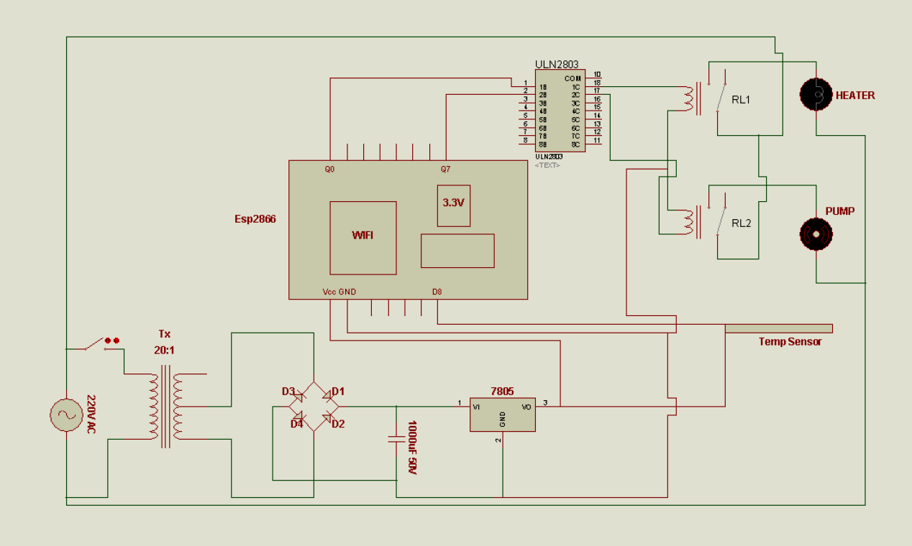

REFERENCES
- P. Bharath,N. Ananth,S. Vijetha, K.V.J.Prakash,(2008),“Wireless Automated Digital Energy Meter in Sustainable Energy Technologies”,International Conference on Sustainable Energy Technologies (ICSET), Vol. 3 – Issue 5, pp 116 - 141.
- V. K. Mehta, (2004), “Principle of Electronic”, S. Chand Publishing Company, Ram Nagar, New Delhi, India, 8th Edition.
- V. VinuDas,(2009),“WirelessCommunicationSystemforEnergy MeterReading”,InternationalConferenceonAdvancesin Recent Technologies in Communication and Computing, ICART, Vol. 5, pp 255 – 269.
- F. N. Omowaye, (2013), Guide to electronics (Project made easy), Jonokase Nig. Co., Warri, Delta State, Nigeria, Second Edition. ISBN 978-978-51847-6-1.
- AbhinandanJain,DilipKumar,JyotiKedia,(2012),‘‘Designand Development of GSM based Energy Meter’’, International Journal of Engineering Research and Technology (IJERT), Vol. 3 - Issue 5, pp 284 - 302.
- B. L.Theraja and A. K.Theraja,(2003), “ElectricalTechnology” S. Chand and CompanyLimited, (Ram Nagar), New Delhi, First Edition.
- Liting Cao,Jingwen Tian,Yanxia Liu,(2008),“Remote Wireless Automatic Meter Reading System Based on Wireless Mess Networks and Embedded Technology”, Fifth IEEE International Symposium on Embedded Computing, pp: 192-197.

